Distributed

Systems

JDBC/MySQL

Java Based

MySQL Database Interface



Student Name : David Martin

Student Number : A00128473

MSc. Software Engineering

Table of Contents

Introduction 3

MySQL Database 4

Creating the MySQL Database 4

JDBC 4

Establishing the JDBC Connection 4

Custom Interface 5

User Login 6

CRUD Operations on the Booking Info Records 8

Create 8

Read 9

Update 10

Delete 11

Serialisation 12

Object Serialisation 12

FileIO & dynamic Html page generation 13

Project Source Code 14

Booking.java 14

ConnectionHelper.java 16

Database_Interface.java 16

Serialisation.java 16

Login.java 18

MainMenu.java 19

Create.java 25

Update.java 27

# Introduction

The aim of this project is to implement a Java based graphical user interface which will allow the user to perform basic CRUD operations on data stored on a remote MySQL database by the use of a JDBC connection.

This project will make use of various Java programming techniques as follows:

* JDBC connection to a MySQL Database
* CRUD Operations on Database Information
* Inheritance & Association
* A custom designed Interface Class
* Serialisation
* Enumeration
* Timers
* FileIO
* The dynamic creation of an Html page based on member data of a Java Object.

The theme of this project is based upon a flight booking system for Aer Lingus. The application is designed to modify, store and retrieve customer & flight booking information.

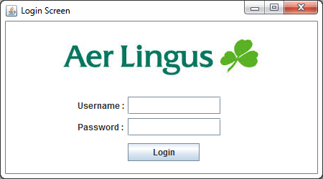

*Figure 1.1 - Application Login Screen*

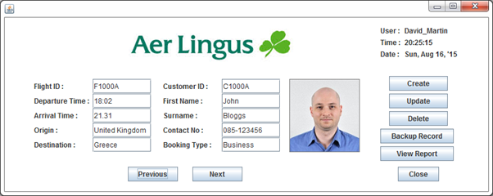

*Figure 1.2 - Main Menu of the JDBC Graphical User Interface*

# MySQL Database

## Creating the MySQL Database

By the use of XAMPP, a MySQL database was created and hosted on the local machine using the default IP address of 127.0.0.1 and port 3306. Using the phpMyAdmin interface, a database called “aer_lingus” was created which consists of the following two tables:

* user_info
  + used to hold the login information for each user of the database
* booking_info
  + used to hold all information in relation to customer and flight bookings

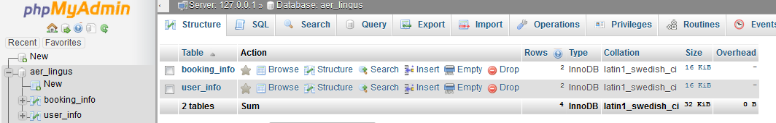

*Figure 1.3 – phpMyAdmin database interface*

# JDBC

## Establishing the JDBC Connection

The “ConnectionHelper” class was design to contain the logic required to connect the Java application to the MySQL database. This class contains the required Connection, Statement and ResultSet object needed for the JDBC connection. The method “DBConnect()” initialises the connection to the database as shown below in Figure 1.4.

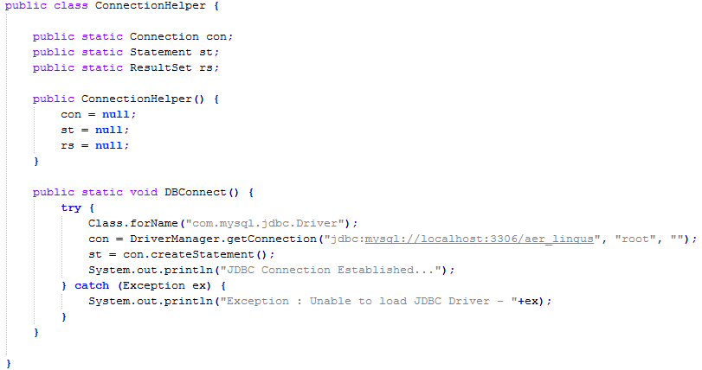

*Figure 1.4 – the ConnectionHelper Class*

# Custom Interface

An Interface class was then designed which contains a pure abstract method called “initialise()”. An Interface is used to enable multiple inheritance in Java, and can be described as a “contract” between the interface and the child class.

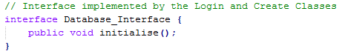

*Figure 1.5 – Interface*

All instances of inheritance using an Interface class, requires all child classes to implement the abstract methods specified within the interface class. This interface will be implemented by both the Login and Update classes. The figures below show the how the “initialise()” method is implemented in each of the specified classes.

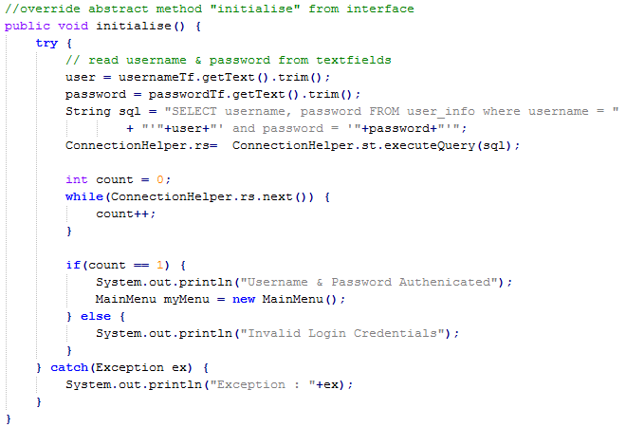

*Figure 1.6 – implementation of the initialise method in the Login class*

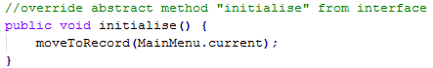

*Figure 1.7 – implementation of the initialise method in the Update class*

# User Login

The Login class provides a JFrame that will authenticate the login credentials entered by the User. For the password textfield, a JPasswordField was used to ensure privacy while the user is logging into the system.

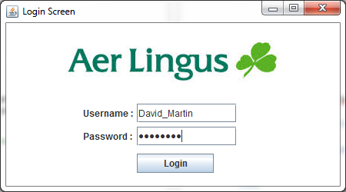

*Figure 1.8 – the Login frame*

When the login credentials are entered and the login button is clicked, the initialise method (see Figure 1.9) is called to connect to the MySQL database to verify the login information against the entries that reside on the user_info table of the database. If the credentials are authenticated, the user will be brought to the Main Menu, otherwise a message dialog box will be displayed to notify the user that incorrect login credentials have been entered.

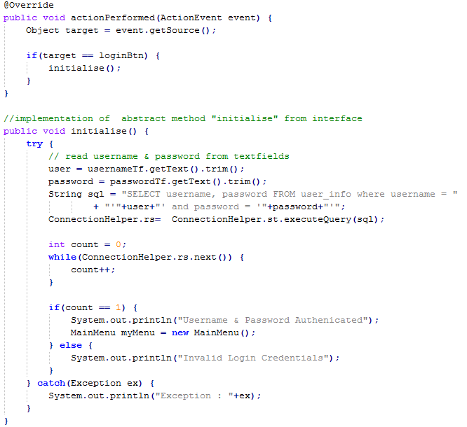

*Figure 1.9 – verifying login credentials*

The Main Menu

On authentication of login details, the main menu will be presented to the user as shown below in figure 2.0.

**

*Figure 2.0 – the Main Menu frame*

Displaying User Info and a Real-Time Clock

The top right hand side of the main menu displays the the username of the current user along with the current date and a realtime clock as shown in figure 2.1.



*Figure 2.1 – user and time displayed on main menu frame*

The real time clock was implemented by adding a timer of 1000ms to the frame. The timer event then was configured to update the time label with the latest time value by the use of a SimpleDateFormat object that was formatted to a String. This String is then displayed in the time label. See sample code of this implementation in figure 2.2 below.

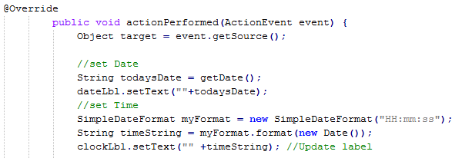

*Figure 2.2 – user and time displayed on main menu frame*

# CRUD Operations on the Booking Info Records

The main menu allows the user to perform CRUD (create, read, update, delete) operations on the records stored on the bookings_info table. The following sections will describe how this was achieved.

## Create

To create a new record, the User shall click on the “Create” button on the main menu. Once clicked, a new JFrame will open allowing the user to enter data in the required fields to build a new booking record. As shown in figure 2.3, the use of JComboBox and JRadioButton elements were implemented on the Create frame for ease of data entry for the user.

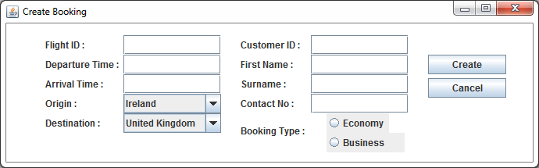

*Figure 2.3 – the Create JFrame*

Once the booking fields have been populated, the User shall click on the “Create” button to add the new entry to the booking_info table that resides on the MySQL database. See figure 2.4 for the code that was used to achieve this.

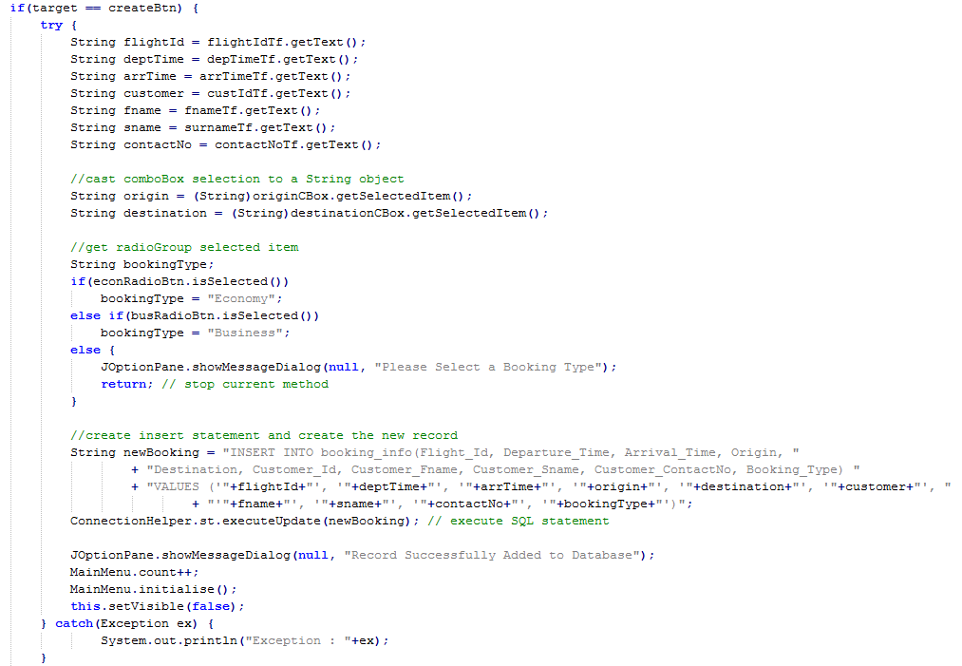

*Figure 2.4 – record creation*

## Read

The user can navigate through the current list of flight bookings by the use of the “Previous” and “Next” buttons that reside on the main menu frame as shown in figure 2.5.

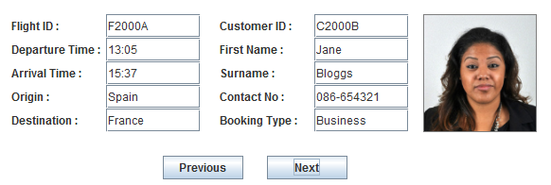

*Figure 2.5 – record navigation*

The moveToRow() method is responsible for navigation the through the resultSet to the desired record. This method receives a Integer as the desired index value at which to display and navigates to this record by the use of a forloop. See figure 2.6 for sample code of the moveToRow() method.

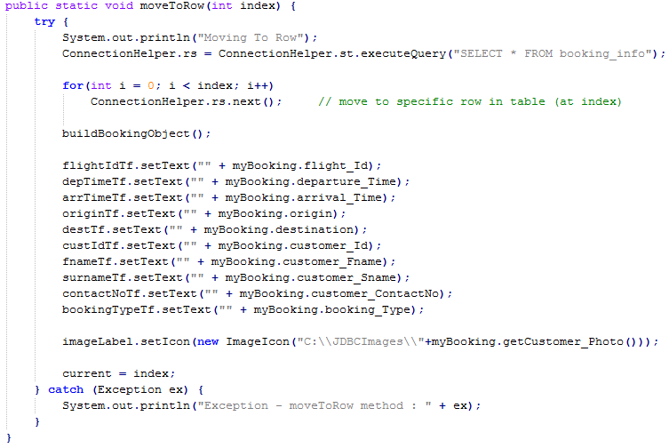

*Figure 2.6 – moveToRow() method*

## Update

To update an existing record, the User shall click on the “Update” button on the main menu. Once clicked, a new JFrame will open giving the user to access to the current record that requires updating. As shown in figure 2.7, the use of JComboBox and JRadioButton elements were implemented on the Create frame for ease of data entry for the user.

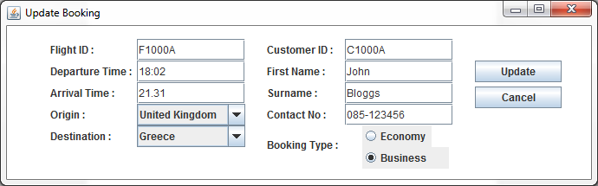

*Figure 2.7 – the Update JFrame*

Once the required changes have been made, the User shall click on the “Update” button to add the update the booking_info table that resides on the MySQL database. See figure 2.8 for the code that was used to achieve this.

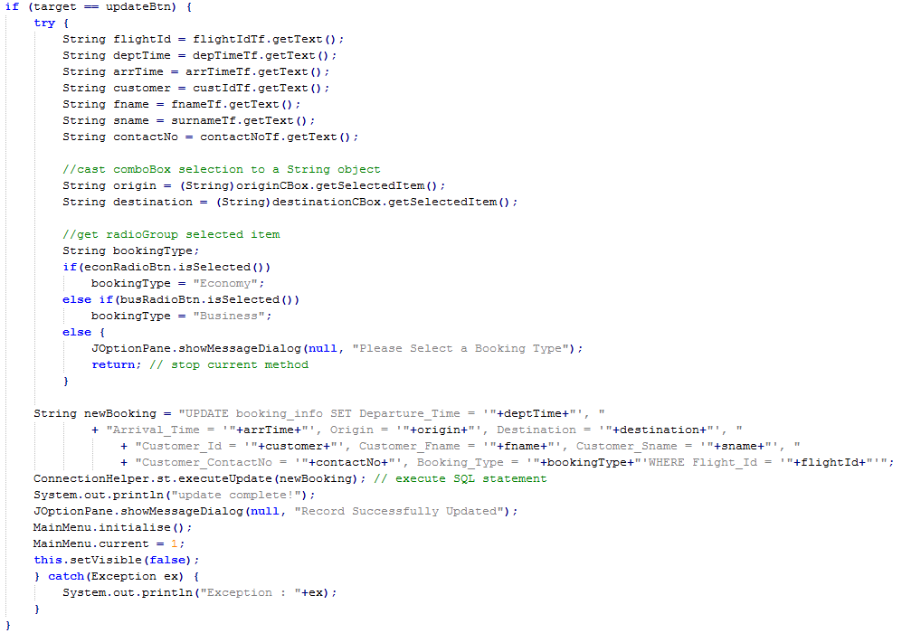

*Figure 2.8 – updating a record*

## Delete

To delete a record, the User can navigate to the desired record on the main menu using the “previous” and “next” buttons. Once the record to be deleted showing on the main menu, the User simply clicks the “Delete” button to remove the record from the MySQL Database. See figure 2.9 for the code that was used to achieve this.

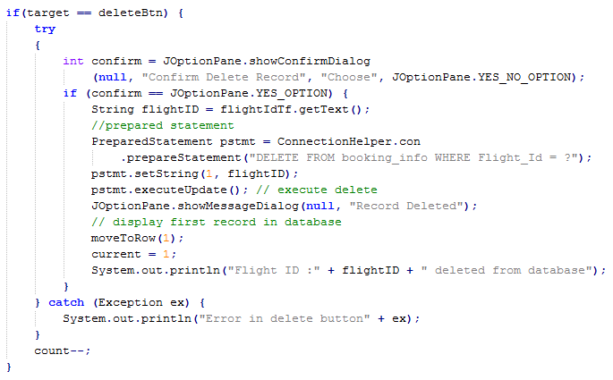

*Figure 2.10 – deleting a record*

The use of a JOptionPane (figure 2.10) was incorporated to prompt the User to confirm the deletion of the record.

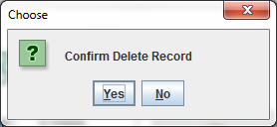

*Figure 2.10 – confirm delete JOptionPane*

# Serialisation

## Object Serialisation

Serialisation was used to allow the User to backup an individual record. To backup an individual record the User simply click on the “Backup Record” button. This will then serialise the specified booking object to the following file: C:\Reports\booking.ser. See figure 3.1 for the code that was used to achieve this.

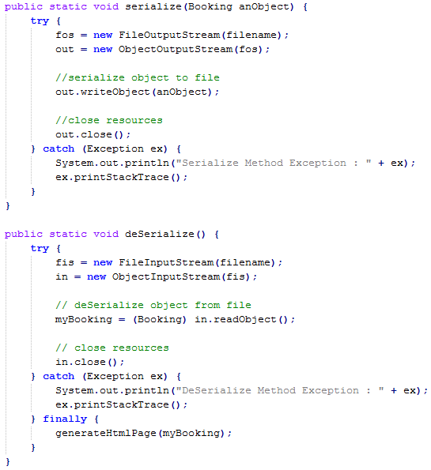

*Figure 3.1 – object serialisation*

# FileIO & dynamic Html page generation

The application was designed to allow for a report to be displayed in the form of an html page based upon the most recent record that was backed up (see figure 3.2).

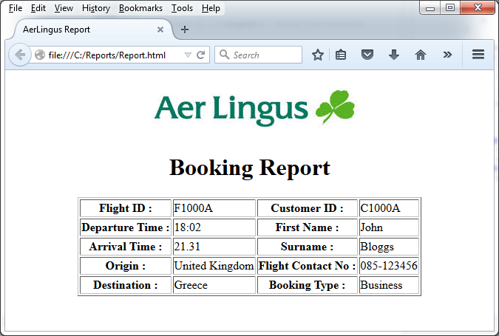

*Figure 3.1 – html report based on serialised object*

This was implemented by using a FIleOutpit stream to create a file called “Report.html”. A PrintStream is then used to populate this file with both html markup and member data from the recently serialised booking object. See figure 3.3 for the code that was used to achieve this.

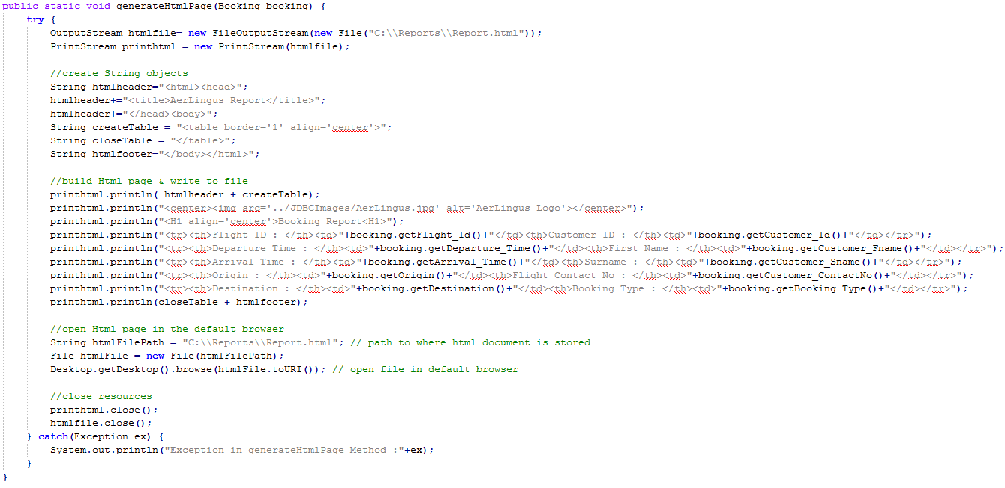

*Figure 3.2 – html page generation*

# Project Source Code

## Booking.java

**import** java**.**io**.**Serializable**;**

public class Booking **implements** Serializable **{**

String flight_Id**;**

String departure_Time**;**

String arrival_Time**;**

String origin**;**

String destination**;**

String customer_Id**;**

String customer_Fname**;**

String customer_Sname**;**

String customer_Photo**;**

String customer_ContactNo**;**

Booking_Type booking_Type**;**

//enumerator for booking_type variable

public static enum Booking_Type **{**

Not_Selected**,**

Economy**,**

Business

**}**

// constructors

public Booking**()** **{**

**this.**flight_Id **=** ""**;**

**this.**departure_Time **=** ""**;**

**this.**arrival_Time **=** ""**;**

**this.**origin **=** ""**;**

**this.**destination **=** ""**;**

**this.**customer_Id **=** ""**;**

**this.**customer_Fname **=** ""**;**

**this.**customer_Sname **=** ""**;**

**this.**customer_Photo **=** ""**;**

**this.**customer_ContactNo **=** ""**;**

**this.**booking_Type **=** Booking_Type**.**Not_Selected**;**

**}**

public Booking**(**String aFlightId**,** String deptTime**,** String arrTime**,** String anOrigin**,**

String aDest**,** String aCustId**,** String aFname**,** String aSname**,** String aPhoto**,**

String aPhoneNo**,** Booking_Type aBookingType **)** **{**

**this.**flight_Id **=** aFlightId**;**

**this.**departure_Time **=** deptTime**;**

**this.**arrival_Time **=** arrTime**;**

**this.**origin **=** anOrigin**;**

**this.**destination **=** aDest**;**

**this.**customer_Id **=** aCustId**;**

**this.**customer_Fname **=** aFname**;**

**this.**customer_Sname **=** aSname**;**

**this.**customer_Photo **=** aPhoto**;**

**this.**customer_ContactNo **=** aPhoneNo**;**

**this.**booking_Type **=** aBookingType**;**

**}**

// getters and setters

public String getFlight_Id**()** **{**

**return** flight_Id**;**

**}**

public void setFlight_Id**(**String flight_Id**)** **{**

**this.**flight_Id **=** flight_Id**;**

**}**

public String getDeparture_Time**()** **{**

**return** departure_Time**;**

**}**

public void setDeparture_Time**(**String departure_Time**)** **{**

**this.**departure_Time **=** departure_Time**;**

**}**

public String getArrival_Time**()** **{**

**return** arrival_Time**;**

**}**

public void setArrival_Time**(**String arrival_Time**)** **{**

**this.**arrival_Time **=** arrival_Time**;**

**}**

public String getOrigin**()** **{**

**return** origin**;**

**}**

public void setOrigin**(**String origin**)** **{**

**this.**origin **=** origin**;**

**}**

public String getDestination**()** **{**

**return** destination**;**

**}**

public void setDestination**(**String destination**)** **{**

**this.**destination **=** destination**;**

**}**

public String getCustomer_Id**()** **{**

**return** customer_Id**;**

**}**

public void setCustomer_Id**(**String customer_Id**)** **{**

**this.**customer_Id **=** customer_Id**;**

**}**

public String getCustomer_Fname**()** **{**

**return** customer_Fname**;**

**}**

public void setCustomer_Fname**(**String customer_Fname**)** **{**

**this.**customer_Fname **=** customer_Fname**;**

**}**

public String getCustomer_Sname**()** **{**

**return** customer_Sname**;**

**}**

public void setCustomer_Sname**(**String customer_Sname**)** **{**

**this.**customer_Sname **=** customer_Sname**;**

**}**

public String getCustomer_Photo**()** **{**

**return** customer_Photo**;**

**}**

public void setCustomer_Photo**(**String customer_Photo**)** **{**

**this.**customer_Photo **=** customer_Photo**;**

**}**

public String getCustomer_ContactNo**()** **{**

**return** customer_ContactNo**;**

**}**

public void setCustomer_ContactNo**(**String customer_ContactNo**)** **{**

**this.**customer_ContactNo **=** customer_ContactNo**;**

**}**

public Booking_Type getBooking_Type**()** **{**

**return** booking_Type**;**

**}**

public Booking_Type getBooking_String**()** **{**

**return** booking_Type**;**

**}**

public void setBooking_Type**(**String type**)** **{**

**this.**booking_Type **=** Booking_Type**.**valueOf**(**type**);**

**}**

@Override

public String toString**()** **{**

**return** "Booking [flight_Id=" **+** flight_Id **+** ", departure_Time=" **+** departure_Time **+** ", arrival_Time="**+** arrival_Time **+** ", origin=" **+** origin **+** ", destination=" **+** destination **+** ", customer_Id=" **+** customer_Id**+** ", customer_Fname=" **+** customer_Fname **+** ", customer_Sname=" **+** customer_Sname **+** ", customer_Photo="**+** customer_Photo **+** ", customer_ContactNo=" **+** customer_ContactNo **+** ", booking_Type=" **+** booking_Type**+** "]"**;**

**}**

**}**

## ConnectionHelper.java

**import** java**.**sql**.**Connection**;**

**import** java**.**sql**.**DriverManager**;**

**import** java**.**sql**.**ResultSet**;**

**import** java**.**sql**.**Statement**;**

public class ConnectionHelper **{**

public static Connection con**;**

public static Statement st**;**

public static ResultSet rs**;**

public ConnectionHelper**()** **{**

con **=** **null;**

st **=** **null;**

rs **=** **null;**

**}**

public static void DBConnect**()** **{**

**try** **{**

Class**.**forName**(**"com.mysql.jdbc.Driver"**);**

con **=** DriverManager**.**getConnection**(**"jdbc:mysql://localhost:3306/aer_lingus"**,**

"root"**,** ""**);**

st **=** con**.**createStatement**();**

System**.**out**.**println**(**"JDBC Connection Established..."**);**

**}** **catch** **(**Exception ex**)** **{**

System**.**out**.**println**(**"Exception : Unable to load JDBC Driver - "**+**ex**);**

**}**

**}**

**}**

## Database_Interface.java

// implemented by the Login and Create Classes

interface Database_Interface **{**

public void initialise**();**

**}**

## Serialisation.java

**import** java**.**awt**.**Desktop**;**

**import** java**.**io**.**File**;**

**import** java**.**io**.**FileInputStream**;**

**import** java**.**io**.**FileOutputStream**;**

**import** java**.**io**.**ObjectInputStream**;**

**import** java**.**io**.**ObjectOutputStream**;**

**import** java**.**io**.**OutputStream**;**

**import** java**.**io**.**PrintStream**;**

public class Serialization **{**

static FileOutputStream fos **=** **null;**

static ObjectOutputStream out **=** **null;**

static FileInputStream fis **=** **null;**

static ObjectInputStream in **=** **null;**

static String filename **=** "C:\\Reports\\booking.ser"**;**

static Booking myBooking **=** **new** Booking**();**

public static void serialize**(**Booking anObject**)** **{**

**try** **{**

fos **=** **new** FileOutputStream**(**filename**);**

out **=** **new** ObjectOutputStream**(**fos**);**

//serialize object to file

out**.**writeObject**(**anObject**);**

//close resources

out**.**close**();**

**}** **catch** **(**Exception ex**)** **{**

System**.**out**.**println**(**"Serialize Method Exception : " **+** ex**);**

ex**.**printStackTrace**();**

**}**

**}**

public static void deSerialize**()** **{**

**try** **{**

fis **=** **new** FileInputStream**(**filename**);**

in **=** **new** ObjectInputStream**(**fis**);**

// deSerialize object from file

myBooking **=** **(**Booking**)** in**.**readObject**();**

// close resources

in**.**close**();**

**}** **catch** **(**Exception ex**)** **{**

System**.**out**.**println**(**"DeSerialize Method Exception : " **+** ex**);**

ex**.**printStackTrace**();**

**}** **finally** **{**

generateHtmlPage**(**myBooking**);**

**}**

**}**

public static void generateHtmlPage**(**Booking booking**)** **{**

**try** **{**

OutputStream htmlfile**=** **new** FileOutputStream**(new** File**(**"C:\\Reports\\Report.html"**));**

PrintStream printhtml **=** **new** PrintStream**(**htmlfile**);**

//create String objects

String htmlheader**=**"<html><head>"**;**

htmlheader**+=**"<title>AerLingus Report</title>"**;**

htmlheader**+=**"</head><body>"**;**

String createTable **=** "<table border='1' align='center'>"**;**

String closeTable **=** "</table>"**;**

String htmlfooter**=**"</body></html>"**;**

//build Html page & write to file

printhtml**.**println**(** htmlheader **+** createTable**);**

printhtml**.**println**(**"<center><img src='../JDBCImages/AerLingus.jpg'

alt='AerLingus Logo'></center>"**);**

printhtml**.**println**(**"<H1 align='center'>Booking Report<H1>"**);**

printhtml**.**println**(**"<tr><th>Flight ID : </th><td>"**+**booking**.**getFlight_Id**()**

**+**"</td><th>Customer ID : </th><td>"**+**booking**.**getCustomer_Id**()+**"</td></tr>"**);**

printhtml**.**println**(**"<tr><th>Departure Time : </th><td>"**+**booking**.**getDeparture_Time**()**

**+**"</td><th>First Name : </th><td>"**+**booking**.**getCustomer_Fname**()+**"</td></tr>"**);**

printhtml**.**println**(**"<tr><th>Arrival Time : </th><td>"**+**booking**.**getArrival_Time**()**

**+**"</td><th>Surname : </th><td>"**+**booking**.**getCustomer_Sname**()+**"</td></tr>"**);**

printhtml**.**println**(**"<tr><th>Origin : </th><td>"**+**booking**.**getOrigin**()**

**+**"</td><th>Flight Contact No :

+ </th><td>"**+**booking**.**getCustomer_ContactNo**()+**"</td></tr>"**);**

printhtml**.**println**(**"<tr><th>Destination : </th><td>"**+**booking**.**getDestination**()**

**+**"</td><th>Booking Type : </th><td>"**+**booking**.**getBooking_Type**()+**"</td></tr>"**);**

printhtml**.**println**(**closeTable **+** htmlfooter**);**

//open Html page in the default browser

String htmlFilePath **=** "C:\\Reports\\Report.html"**;** // path to where html document

is stored

File htmlFile **=** **new** File**(**htmlFilePath**);**

Desktop**.**getDesktop**().**browse**(**htmlFile**.**toURI**());** // open file in default browser

//close resources

printhtml**.**close**();**

htmlfile**.**close**();**

**}** **catch(**Exception ex**)** **{**

System**.**out**.**println**(**"Exception in generateHtmlPage Method :"**+**ex**);**

**}**

**}**

**}**

## Login.java

**import** java**.**awt**.**Color**;**

**import** java**.**awt**.**event**.**ActionEvent**;**

**import** java**.**awt**.**event**.**ActionListener**;**

**import** javax**.**swing**.**ImageIcon**;**

**import** javax**.**swing**.**JButton**;**

**import** javax**.**swing**.**JFrame**;**

**import** javax**.**swing**.**JLabel**;**

**import** javax**.**swing**.**JPasswordField**;**

**import** javax**.**swing**.**JTextField**;**

public class Login **extends** JFrame **implements** Database_Interface**,** ActionListener **{**

private JLabel logoLbl**;**

private JLabel userNameLbl**;**

private JLabel passwordLbl**;**

private JTextField usernameTf**;**

private JPasswordField passwordTf**;**

private JButton loginBtn**;**

public static String user **=** ""**;**

private String password **=** ""**;**

public Login**()** **{**

**super(**"Login Screen"**);**

// Initialize connection

ConnectionHelper**.**DBConnect**();**

//construct components

userNameLbl **=** **new** JLabel **(**"Username :"**);**

passwordLbl **=** **new** JLabel **(**"Password :"**);**

usernameTf **=** **new** JTextField **(**5**);**

passwordTf **=** **new** JPasswordField **(**5**);**

loginBtn **=** **new** JButton **(**"Login"**);**

// Add logo image to label

ImageIcon image **=** **new** ImageIcon**(**"C:\\JDBCImages\\AerLingus.jpg"**);** // ImageIcon

logoLbl **=** **new** JLabel**(**""**,** image**,** JLabel**.**CENTER**);** // embed image into imageLabel

//adjust size and set layout

setSize **(**450**,** 250**);**

setLayout **(null);**

//add components

add **(**userNameLbl**);**

add **(**passwordLbl**);**

add **(**usernameTf**);**

add **(**passwordTf**);**

add **(**loginBtn**);**

add **(**logoLbl**);**

//set component bounds (only needed by Absolute Positioning)

userNameLbl**.**setBounds **(**100**,** 105**,** 75**,** 25**);**

passwordLbl**.**setBounds **(**100**,** 135**,** 75**,** 25**);**

usernameTf**.**setBounds **(**170**,** 105**,** 130**,** 25**);**

passwordTf**.**setBounds **(**170**,** 135**,** 130**,** 25**);**

loginBtn**.**setBounds **(**170**,** 170**,** 100**,** 25**);**

logoLbl**.**setBounds **(**60**,** 10**,** 300**,** 75**);**

//add actionListener to Login Button

loginBtn**.**addActionListener**(this);**

setDefaultCloseOperation **(**EXIT_ON_CLOSE**);**

getContentPane**().**setBackground**(**Color**.**WHITE**);**

setLocationRelativeTo**(null);** // center Frame on screen

setVisible **(true);**

**}**

@Override

public void actionPerformed**(**ActionEvent event**)** **{**

Object target **=** event**.**getSource**();**

**if(**target **==** loginBtn**)** **{**

initialise**();**

**}**

**}**

//implementation of abstract method "initialise" from interface

public void initialise**()** **{**

**try** **{**

// read username & password from textfields

user **=** usernameTf**.**getText**().**trim**();**

password **=** passwordTf**.**getText**().**trim**();**

String sql **=** "SELECT username, password FROM user_info where username = "

**+** "'"**+**user**+**"' and password = '"**+**password**+**"'"**;**

ConnectionHelper**.**rs**=** ConnectionHelper**.**st**.**executeQuery**(**sql**);**

int count **=** 0**;**

**while(**ConnectionHelper**.**rs**.**next**())** **{**

count**++;**

**}**

**if(**count **==** 1**)** **{**

System**.**out**.**println**(**"Username & Password Authenicated"**);**

MainMenu myMenu **=** **new** MainMenu**();**

**}** **else** **{**

System**.**out**.**println**(**"Invalid Login Credentials"**);**

**}**

**}** **catch(**Exception ex**)** **{**

System**.**out**.**println**(**"Exception : "**+**ex**);**

**}**

**}**

public static void main **(**String**[]** args**)** **{**

JFrame myLogin **=** **new** Login**();**

**}**

**}**

## MainMenu.java

**import** java**.**awt**.**Color**;**

**import** java**.**awt**.**event**.**ActionEvent**;**

**import** java**.**awt**.**event**.**ActionListener**;**

**import** java**.**sql**.**PreparedStatement**;**

**import** java**.**text**.**SimpleDateFormat**;**

**import** java**.**util**.**Date**;**

**import** javax**.**swing**.**BorderFactory**;**

**import** javax**.**swing**.**ImageIcon**;**

**import** javax**.**swing**.**JButton**;**

**import** javax**.**swing**.**JFrame**;**

**import** javax**.**swing**.**JLabel**;**

**import** javax**.**swing**.**JOptionPane**;**

**import** javax**.**swing**.**JTextField**;**

**import** javax**.**swing**.**Timer**;**

**import** javax**.**swing**.**border**.**Border**;**

public class MainMenu **extends** JFrame **implements** ActionListener **{**

private JLabel flightIdLbl**;**

private JLabel deptTimeLbl**;**

private JLabel arrivalTimeLbl**;**

private JLabel originLbl**;**

private JLabel destinationlbl**;**

private JLabel custIdLbl**;**

private JLabel fnameLbl**;**

private JLabel snameLbl**;**

private JLabel contactNoLbl**;**

private JLabel bookingType**;**

private static JTextField flightIdTf**;**

private static JTextField depTimeTf**;**

private static JTextField arrTimeTf**;**

private static JTextField originTf**;**

private static JTextField destTf**;**

private static JTextField custIdTf**;**

private static JTextField fnameTf**;**

private static JTextField surnameTf**;**

private static JTextField contactNoTf**;**

private static JTextField bookingTypeTf**;**

private JButton prevBtn**;**

private JButton nextBtn**;**

private JButton createBtn**;**

private JButton updateBtn**;**

private JButton deleteBtn**;**

private JButton closeBtn**;**

private JButton backupBtn**;**

private JButton reportBtn**;**

private static JLabel imageLabel**;**

private JLabel clockLbl**;**

private JLabel dateLbl**;**

private JLabel userLbl**;**

private JLabel loggedDescLbl**;**

private JLabel timeDescLbl**;**

private JLabel dateDescLbl**;**

private JLabel logoLbl**;**

//create a Booking object

public static Booking myBooking **=** **new** Booking**();**

//record navigation variables

public static int count **=** 0**;**

public static int current **=** 0**;**

public MainMenu**()** **{**

//construct components

flightIdLbl **=** **new** JLabel **(**"Flight ID :"**);**

deptTimeLbl **=** **new** JLabel **(**"Departure Time :"**);**

arrivalTimeLbl **=** **new** JLabel **(**"Arrival Time :"**);**

originLbl **=** **new** JLabel **(**"Origin :"**);**

destinationlbl **=** **new** JLabel **(**"Destination :"**);**

custIdLbl **=** **new** JLabel **(**"Customer ID :"**);**

fnameLbl **=** **new** JLabel **(**"First Name :"**);**

snameLbl **=** **new** JLabel **(**"Surname :"**);**

contactNoLbl **=** **new** JLabel **(**"Contact No :"**);**

bookingType **=** **new** JLabel **(**"Booking Type :"**);**

flightIdTf **=** **new** JTextField **(**5**);**

depTimeTf **=** **new** JTextField **(**5**);**

arrTimeTf **=** **new** JTextField **(**5**);**

originTf **=** **new** JTextField **(**5**);**

destTf **=** **new** JTextField **(**5**);**

custIdTf **=** **new** JTextField **(**5**);**

fnameTf **=** **new** JTextField **(**5**);**

surnameTf **=** **new** JTextField **(**5**);**

contactNoTf **=** **new** JTextField **(**5**);**

bookingTypeTf **=** **new** JTextField **(**5**);**

prevBtn **=** **new** JButton **(**"Previous"**);**

nextBtn **=** **new** JButton **(**"Next"**);**

createBtn **=** **new** JButton **(**"Create"**);**

updateBtn **=** **new** JButton **(**"Update"**);**

deleteBtn **=** **new** JButton **(**"Delete"**);**

closeBtn **=** **new** JButton **(**"Close"**);**

imageLabel **=** **new** JLabel **(**""**);**

backupBtn **=** **new** JButton **(**"Backup Record"**);**

reportBtn **=** **new** JButton **(**"View Report"**);**

clockLbl **=** **new** JLabel **();**

dateLbl **=** **new** JLabel **();**

userLbl **=** **new** JLabel **(**Login**.**user**);**

loggedDescLbl **=** **new** JLabel **(**"User : "**);**

timeDescLbl **=** **new** JLabel **(**"Time : "**);**

dateDescLbl **=** **new** JLabel **(**"Date : "**);**

// Add logo image to label

ImageIcon image **=** **new** ImageIcon**(**"C:\\JDBCImages\\AerLingus.jpg"**);** // ImageIcon

logoLbl **=** **new** JLabel**(**""**,** image**,** JLabel**.**CENTER**);** // embed image into imageLabel

//adjust size and set layout

setSize **(**840**,** 335**);**

setLayout **(null);**

//add components

add **(**flightIdLbl**);**

add **(**deptTimeLbl**);**

add **(**arrivalTimeLbl**);**

add **(**originLbl**);**

add **(**destinationlbl**);**

add **(**custIdLbl**);**

add **(**fnameLbl**);**

add **(**snameLbl**);**

add **(**contactNoLbl**);**

add **(**bookingType**);**

add **(**flightIdTf**);**

add **(**depTimeTf**);**

add **(**arrTimeTf**);**

add **(**originTf**);**

add **(**destTf**);**

add **(**custIdTf**);**

add **(**fnameTf**);**

add **(**surnameTf**);**

add **(**contactNoTf**);**

add **(**bookingTypeTf**);**

add **(**prevBtn**);**

add **(**nextBtn**);**

add **(**createBtn**);**

add **(**updateBtn**);**

add **(**deleteBtn**);**

add **(**closeBtn**);**

add **(**imageLabel**);**

add **(**backupBtn**);**

add **(**reportBtn**);**

add **(**clockLbl**);**

add **(**dateLbl**);**

add **(**userLbl**);**

add **(**loggedDescLbl**);**

add **(**timeDescLbl**);**

add **(**dateDescLbl**);**

add **(**logoLbl**);**

//add border to customerImage label

Border border **=** BorderFactory**.**createLineBorder**(**Color**.**gray**,** 1**);**

imageLabel**.**setBorder**(**border**);**

//set component bounds (only needed by Absolute Positioning)

flightIdLbl**.**setBounds **(**50**,** 105**,** 100**,** 25**);**

deptTimeLbl**.**setBounds **(**50**,** 130**,** 100**,** 25**);**

arrivalTimeLbl**.**setBounds **(**50**,** 155**,** 100**,** 25**);**

originLbl**.**setBounds **(**50**,** 180**,** 100**,** 25**);**

destinationlbl**.**setBounds **(**50**,** 205**,** 100**,** 25**);**

custIdLbl**.**setBounds **(**270**,** 105**,** 100**,** 25**);**

fnameLbl**.**setBounds **(**270**,** 130**,** 100**,** 25**);**

snameLbl**.**setBounds **(**270**,** 155**,** 100**,** 25**);**

contactNoLbl**.**setBounds **(**270**,** 180**,** 100**,** 25**);**

bookingType**.**setBounds **(**270**,** 205**,** 100**,** 25**);**

flightIdTf**.**setBounds **(**150**,** 105**,** 100**,** 25**);**

depTimeTf**.**setBounds **(**150**,** 130**,** 100**,** 25**);**

arrTimeTf**.**setBounds **(**150**,** 155**,** 100**,** 25**);**

originTf**.**setBounds **(**150**,** 180**,** 100**,** 25**);**

destTf**.**setBounds **(**150**,** 205**,** 100**,** 25**);**

custIdTf**.**setBounds **(**370**,** 105**,** 100**,** 25**);**

fnameTf**.**setBounds **(**370**,** 130**,** 100**,** 25**);**

surnameTf**.**setBounds **(**370**,** 155**,** 100**,** 25**);**

contactNoTf**.**setBounds **(**370**,** 180**,** 100**,** 25**);**

bookingTypeTf**.**setBounds **(**370**,** 205**,** 100**,** 25**);**

prevBtn**.**setBounds **(**210**,** 255**,** 85**,** 25**);**

nextBtn**.**setBounds **(**320**,** 255**,** 85**,** 25**);**

createBtn**.**setBounds **(**655**,** 100**,** 100**,** 25**);**

updateBtn**.**setBounds **(**655**,** 130**,** 100**,** 25**);**

deleteBtn**.**setBounds **(**655**,** 160**,** 100**,** 25**);**

closeBtn**.**setBounds **(**670**,** 255**,** 70**,** 25**);**

imageLabel**.**setBounds **(**485**,** 105**,** 120**,** 125**);**

backupBtn**.**setBounds **(**640**,** 190**,** 125**,** 25**);**

reportBtn**.**setBounds **(**640**,** 220**,** 125**,** 25**);**

clockLbl**.**setBounds **(**681**,** 30**,** 110**,** 25**);**

dateLbl**.**setBounds **(**681**,** 50**,** 110**,** 25**);**

userLbl**.**setBounds **(**681**,** 10**,** 100**,** 25**);**

loggedDescLbl**.**setBounds **(**640**,** 10**,** 100**,** 25**);**

timeDescLbl**.**setBounds **(**640**,** 30**,** 45**,** 25**);**

dateDescLbl**.**setBounds **(**640**,** 50**,** 45**,** 25**);**

logoLbl**.**setBounds **(**160**,** 10**,** 300**,** 80**);**

//add actionlisteners to buttons

prevBtn**.**addActionListener**(this);**

nextBtn**.**addActionListener**(this);**

createBtn**.**addActionListener**(this);**

updateBtn**.**addActionListener**(this);**

deleteBtn**.**addActionListener**(this);**

closeBtn**.**addActionListener**(this);**

backupBtn**.**addActionListener**(this);**

reportBtn**.**addActionListener**(this);**

//populate textfields

initialise**();**

//create & initialise timer for real-time clock

**new** Timer**(**1000**,** **this).**start**();**

setDefaultCloseOperation **(**EXIT_ON_CLOSE**);**

getContentPane**().**setBackground**(**Color**.**WHITE**);**

setLocationRelativeTo**(null);** // center Frame on screen

setVisible **(true);**

**}**

public static void initialise**()** **{**

**try** **{**

ConnectionHelper**.**rs **=** ConnectionHelper**.**st**.**executeQuery**(**"SELECT * FROM

booking_info"**);**

//count number of booking records

count **=** 0**;**

**while(**ConnectionHelper**.**rs**.**next**())**

count**++;**

System**.**out**.**println**(**"No. of Booking Records : "**+**count**);**

//navigate the rescordSet back to the first record

ConnectionHelper**.**rs**.**first**();**

current **=** 1**;**

myBooking**.**setFlight_Id**(**ConnectionHelper**.**rs**.**getString**(**"Flight_id"**));**

myBooking**.**setDeparture_Time**(**ConnectionHelper**.**rs**.**getString**(**"Departure_Time"**));**

myBooking**.**setArrival_Time**(**ConnectionHelper**.**rs**.**getString**(**"Arrival_Time"**));**

myBooking**.**setOrigin**(**ConnectionHelper**.**rs**.**getString**(**"Origin"**));**

myBooking**.**setDestination**(**ConnectionHelper**.**rs**.**getString**(**"Destination"**));**

myBooking**.**setCustomer_Id**(**ConnectionHelper**.**rs**.**getString**(**"Customer_Id"**));**

myBooking**.**setCustomer_Fname**(**ConnectionHelper**.**rs**.**getString**(**"Customer_Fname"**));**

myBooking**.**setCustomer_Sname**(**ConnectionHelper**.**rs**.**getString**(**"Customer_Sname"**));**

myBooking**.**setCustomer_Photo**(**ConnectionHelper**.**rs**.**getString**(**"Customer_Photo"**));**

myBooking**.**setCustomer_ContactNo**(**ConnectionHelper**.**rs**.**getString**(**"Customer_ContactNo"**));**

myBooking**.**setBooking_Type**(**ConnectionHelper**.**rs**.**getString**(**"Booking_Type"**));**

myBooking**.**setCustomer_Photo**(**ConnectionHelper**.**rs**.**getString**(**"Customer_Photo"**));**

flightIdTf**.**setText**(**"" **+** myBooking**.**flight_Id**);**

depTimeTf**.**setText**(**"" **+** myBooking**.**departure_Time**);**

arrTimeTf**.**setText**(**"" **+** myBooking**.**arrival_Time**);**

originTf**.**setText**(**"" **+** myBooking**.**origin**);**

destTf**.**setText**(**"" **+** myBooking**.**destination**);**

custIdTf**.**setText**(**"" **+** myBooking**.**customer_Id**);**

fnameTf**.**setText**(**"" **+** myBooking**.**customer_Fname**);**

surnameTf**.**setText**(**"" **+** myBooking**.**customer_Sname**);**

contactNoTf**.**setText**(**"" **+** myBooking**.**customer_ContactNo**);**

bookingTypeTf**.**setText**(**"" **+** myBooking**.**booking_Type**);**

imageLabel**.**setIcon**(new**

ImageIcon**(**"C:\\JDBCImages\\"**+**myBooking**.**getCustomer_Photo**()));**

**}** **catch** **(**Exception ex**)** **{**

System**.**out**.**println**(**"Exception - initialise method : " **+** ex**);**

**}**

**}**

@Override

public void actionPerformed**(**ActionEvent event**)** **{**

Object target **=** event**.**getSource**();**

//set Date

String todaysDate **=** getDate**();**

dateLbl**.**setText**(**""**+**todaysDate**);**

//set Time

SimpleDateFormat myFormat **=** **new** SimpleDateFormat**(**"HH:mm:ss"**);**

String timeString **=** myFormat**.**format**(new** Date**());**

clockLbl**.**setText**(**"" **+**timeString**);** //Update label text

**if(**target **==** nextBtn**)** **{**

**try** **{**

**if** **(**current **!=** count**)** **{**

moveToRow**(**current **+** 1**);**

**}**

**}** **catch** **(**Exception ex**)** **{**

System**.**out**.**println**(**"Error in next button : " **+** ex**);**

**}**

**}**

**if(**target **==** prevBtn**)** **{**

**try** **{**

**if** **(**current **!=** 1**)** **{**

moveToRow**(**current **-** 1**);**

**}**

**}** **catch** **(**Exception ex**)** **{**

System**.**out**.**println**(**"Error in previous button : " **+** ex**);**

**}**

**}**

**if(**target **==** createBtn**)** **{**

Create myCreate **=** **new** Create**();**

**}**

**if(**target **==** updateBtn**)** **{**

Update myUpdate **=** **new** Update**();**

**}**

**if(**target **==** deleteBtn**)** **{**

**try**

**{**

int confirm **=** JOptionPane**.**showConfirmDialog**(null,** "Confirm Delete Record"**,**

"Choose"**,** JOptionPane**.**YES_NO_OPTION**);**

**if** **(**confirm **==** JOptionPane**.**YES_OPTION**)** **{**

String flightID **=** flightIdTf**.**getText**();**

//prepared statement

PreparedStatement pstmt **=** ConnectionHelper**.**con**.**prepareStatement**(**"DELETE

FROM booking_info WHERE Flight_Id = ?"**);**

pstmt**.**setString**(**1**,** flightID**);**

pstmt**.**executeUpdate**();** // execute delete

JOptionPane**.**showMessageDialog**(null,** "Record Deleted"**);**

// display first record in database

moveToRow**(**1**);**

current **=** 1**;**

System**.**out**.**println**(**"Flight ID :" **+** flightID **+** " deleted from database"**);**

**}**

**}** **catch** **(**Exception ex**)** **{**

System**.**out**.**println**(**"Error in delete button" **+** ex**);**

**}**

count**--;**

**}**

**if(**target **==** backupBtn**)** **{**

buildBookingObject**();**

Serialization**.**serialize**(**myBooking**);**

JOptionPane**.**showMessageDialog**(null,** "Record Successfully Updated"**);**

**}**

**if(**target **==** reportBtn**)** **{**

Serialization**.**deSerialize**();**

**}**

**if(**target **==** closeBtn**)** **{**

int confirm **=** JOptionPane**.**showConfirmDialog**(null,** "Are you sure you wish to

EXIT?"**,** "Choose"**,** JOptionPane**.**YES_NO_OPTION**);**

**if** **(**confirm **==** JOptionPane**.**YES_OPTION**)** **{**

**try** **{**

ConnectionHelper**.**rs**.**close**();**

dispose**();**

System**.**exit**(**0**);**

**}** **catch** **(**Exception ex**)** **{**

System**.**out**.**println**(**"Exit Button Error " **+** ex**);**

**}**

**}**

**}**

**}**

public static void moveToRow**(**int index**)** **{**

**try** **{**

System**.**out**.**println**(**"Moving To Row"**);**

ConnectionHelper**.**rs **=** ConnectionHelper**.**st**.**executeQuery**(**"SELECT * FROM

booking_info"**);**

**for(**int i **=** 0**;** i **<** index**;** i**++)**

ConnectionHelper**.**rs**.**next**();** // move to specific row in table (at index)

buildBookingObject**();**

flightIdTf**.**setText**(**"" **+** myBooking**.**flight_Id**);**

depTimeTf**.**setText**(**"" **+** myBooking**.**departure_Time**);**

arrTimeTf**.**setText**(**"" **+** myBooking**.**arrival_Time**);**

originTf**.**setText**(**"" **+** myBooking**.**origin**);**

destTf**.**setText**(**"" **+** myBooking**.**destination**);**

custIdTf**.**setText**(**"" **+** myBooking**.**customer_Id**);**

fnameTf**.**setText**(**"" **+** myBooking**.**customer_Fname**);**

surnameTf**.**setText**(**"" **+** myBooking**.**customer_Sname**);**

contactNoTf**.**setText**(**"" **+** myBooking**.**customer_ContactNo**);**

bookingTypeTf**.**setText**(**"" **+** myBooking**.**booking_Type**);**

imageLabel**.**setIcon**(new**

ImageIcon**(**"C:\\JDBCImages\\"**+**myBooking**.**getCustomer_Photo**()));**

current **=** index**;**

**}** **catch** **(**Exception ex**)** **{**

System**.**out**.**println**(**"Exception - moveToRow method : " **+** ex**);**

**}**

**}**

public static void buildBookingObject**()** **{**

**try** **{**

myBooking**.**setFlight_Id**(**ConnectionHelper**.**rs**.**getString**(**"Flight_id"**));**

myBooking**.**setDeparture_Time**(**ConnectionHelper**.**rs**.**getString**(**"Departure_Time"**));**

myBooking**.**setArrival_Time**(**ConnectionHelper**.**rs**.**getString**(**"Arrival_Time"**));**

myBooking**.**setOrigin**(**ConnectionHelper**.**rs**.**getString**(**"Origin"**));**

myBooking**.**setDestination**(**ConnectionHelper**.**rs**.**getString**(**"Destination"**));**

myBooking**.**setCustomer_Id**(**ConnectionHelper**.**rs**.**getString**(**"Customer_Id"**));**

myBooking**.**setCustomer_Fname**(**ConnectionHelper**.**rs**.**getString**(**"Customer_Fname"**));**

myBooking**.**setCustomer_Sname**(**ConnectionHelper**.**rs**.**getString**(**"Customer_Sname"**));**

myBooking**.**setCustomer_Photo**(**ConnectionHelper**.**rs**.**getString**(**"Customer_Photo"**));**

myBooking**.**setCustomer_ContactNo**(**ConnectionHelper**.**rs**.**getString**(**"Customer_ContactNo"**));**

myBooking**.**setBooking_Type**(**ConnectionHelper**.**rs**.**getString**(**"Booking_Type"**));**

myBooking**.**setCustomer_Photo**(**ConnectionHelper**.**rs**.**getString**(**"Customer_Photo"**));**

**}** **catch** **(**Exception ex**)** **{**

System**.**out**.**println**(**"Exception in buildBookingObject Method : " **+** ex**);**

**}**

**}**

public String getDate**()** // format todays Date and return it as a String

**{**

SimpleDateFormat myFormat **=** **new** SimpleDateFormat**(**"EEE, MMM d, ''yy"**);**

String dateString **=** myFormat**.**format**(new** Date**());**

**return** dateString**;**

**}**

public static void main**(**String args**[])** **{**

MainMenu myMenu **=** **new** MainMenu**();**

**}**

**}**

## Create.java

**import** java**.**awt**.*;**

**import** java**.**awt**.**event**.*;**

**import** javax**.**swing**.*;**

**import** javax**.**swing**.**event**.*;**

public class Create **extends** JFrame **implements** ActionListener **{**

private JLabel flightIdLbl**;**

private JLabel arrivalTimeLbl**;**

private JLabel deptTimeLbl**;**

private JLabel originLbl**;**

private JLabel destinationlbl**;**

private JLabel custIdLbl**;**

private JLabel fnameLbl**;**

private JLabel snameLbl**;**

private JLabel contactNoLbl**;**

private JLabel bookingType**;**

private JTextField flightIdTf**;**

private JTextField depTimeTf**;**

private JTextField arrTimeTf**;**

private JTextField custIdTf**;**

private JTextField fnameTf**;**

private JTextField surnameTf**;**

private JTextField contactNoTf**;**

private JButton createBtn**;**

private JButton cancelBtn**;**

private JComboBox originCBox**;**

private JComboBox destinationCBox**;**

private JRadioButton econRadioBtn**;**

private JRadioButton busRadioBtn**;**

private ButtonGroup bg**;**

public Create**()** **{**

**super(**"Create Booking"**);**

//construct preComponents

String**[]** originCBoxItems **=** **{**"Ireland"**,** "United Kingdom"**,** "France"**,** "Germany"**,** "Spain"**,**

"Greece"**,** "Poland"**,** "Holland"**,** "Sweden"**,** "Norway"**,** "Portugal"**,** "Italy"**};**

String**[]** destinationCBoxItems **=** **{**"United Kingdom"**,** "France"**,** "Germany"**,** "Spain"**,**

"Greece"**,** "Poland"**,** "Holland"**,** "Sweden"**,** "Norway"**,** "Portugal"**,** "Italy"**};**

//construct components

flightIdLbl **=** **new** JLabel **(**"Flight ID :"**);**

deptTimeLbl **=** **new** JLabel **(**"Departure Time :"**);**

arrivalTimeLbl **=** **new** JLabel **(**"Arrival Time :"**);**

originLbl **=** **new** JLabel **(**"Origin :"**);**

destinationlbl **=** **new** JLabel **(**"Destination :"**);**

custIdLbl **=** **new** JLabel **(**"Customer ID :"**);**

fnameLbl **=** **new** JLabel **(**"First Name :"**);**

snameLbl **=** **new** JLabel **(**"Surname :"**);**

contactNoLbl **=** **new** JLabel **(**"Contact No :"**);**

bookingType **=** **new** JLabel **(**"Booking Type :"**);**

flightIdTf **=** **new** JTextField **(**5**);**

depTimeTf **=** **new** JTextField **(**5**);**

arrTimeTf **=** **new** JTextField **(**5**);**

custIdTf **=** **new** JTextField **(**5**);**

fnameTf **=** **new** JTextField **(**5**);**

surnameTf **=** **new** JTextField **(**5**);**

contactNoTf **=** **new** JTextField **(**5**);**

createBtn **=** **new** JButton **(**"Create"**);**

cancelBtn **=** **new** JButton **(**"Cancel"**);**

originCBox **=** **new** JComboBox **(**originCBoxItems**);**

destinationCBox **=** **new** JComboBox **(**destinationCBoxItems**);**

econRadioBtn **=** **new** JRadioButton **(**"Economy"**);**

busRadioBtn **=** **new** JRadioButton **(**"Business"**);**

bg **=** **new** ButtonGroup**();**

bg**.**add**(**econRadioBtn**);**

bg**.**add**(**busRadioBtn**);**

//adjust size and set layout

setSize **(**690**,** 215**);**

setLayout **(null);**

//add components

add **(**flightIdLbl**);**

add **(**deptTimeLbl**);**

add **(**arrivalTimeLbl**);**

add **(**originLbl**);**

add **(**destinationlbl**);**

add **(**custIdLbl**);**

add **(**fnameLbl**);**

add **(**snameLbl**);**

add **(**contactNoLbl**);**

add **(**bookingType**);**

add **(**flightIdTf**);**

add **(**depTimeTf**);**

add **(**arrTimeTf**);**

add **(**custIdTf**);**

add **(**fnameTf**);**

add **(**surnameTf**);**

add **(**contactNoTf**);**

add **(**createBtn**);**

add **(**cancelBtn**);**

add **(**originCBox**);**

add **(**destinationCBox**);**

add **(**econRadioBtn**);**

add **(**busRadioBtn**);**

//set component bounds (only needed by Absolute Positioning)

flightIdLbl**.**setBounds **(**50**,** 15**,** 100**,** 25**);**

deptTimeLbl**.**setBounds **(**50**,** 40**,** 100**,** 25**);**

arrivalTimeLbl**.**setBounds **(**50**,** 65**,** 100**,** 25**);**

originLbl**.**setBounds **(**50**,** 90**,** 100**,** 25**);**

destinationlbl**.**setBounds **(**50**,** 115**,** 100**,** 25**);**

custIdLbl**.**setBounds **(**300**,** 15**,** 100**,** 25**);**

fnameLbl**.**setBounds **(**300**,** 40**,** 100**,** 25**);**

snameLbl**.**setBounds **(**300**,** 65**,** 100**,** 25**);**

contactNoLbl**.**setBounds **(**300**,** 90**,** 100**,** 25**);**

bookingType**.**setBounds **(**300**,** 125**,** 100**,** 25**);**

flightIdTf**.**setBounds **(**150**,** 15**,** 125**,** 25**);**

depTimeTf**.**setBounds **(**150**,** 40**,** 125**,** 25**);**

arrTimeTf**.**setBounds **(**150**,** 65**,** 125**,** 25**);**

custIdTf**.**setBounds **(**390**,** 15**,** 125**,** 25**);**

fnameTf**.**setBounds **(**390**,** 40**,** 125**,** 25**);**

surnameTf**.**setBounds **(**390**,** 65**,** 125**,** 25**);**

contactNoTf**.**setBounds **(**390**,** 90**,** 125**,** 25**);**

createBtn**.**setBounds **(**540**,** 40**,** 100**,** 25**);**

cancelBtn**.**setBounds **(**540**,** 70**,** 100**,** 25**);**

originCBox**.**setBounds **(**150**,** 90**,** 125**,** 25**);**

destinationCBox**.**setBounds **(**150**,** 115**,** 125**,** 25**);**

econRadioBtn**.**setBounds **(**410**,** 115**,** 80**,** 25**);**

busRadioBtn**.**setBounds **(**410**,** 140**,** 100**,** 25**);**

//add ActionListeners to buttons

createBtn**.**addActionListener**(this);**

cancelBtn**.**addActionListener**(this);**

setDefaultCloseOperation **(**EXIT_ON_CLOSE**);**

getContentPane**().**setBackground**(**Color**.**WHITE**);**

setLocationRelativeTo**(null);** // center Frame on screen

setVisible **(true);**

**}**

@Override

public void actionPerformed**(**ActionEvent event**)** **{**

Object target **=** event**.**getSource**();**

**if(**target **==** createBtn**)** **{**

**try** **{**

String flightId **=** flightIdTf**.**getText**();**

String deptTime **=** depTimeTf**.**getText**();**

String arrTime **=** arrTimeTf**.**getText**();**

String customer **=** custIdTf**.**getText**();**

String fname **=** fnameTf**.**getText**();**

String sname **=** surnameTf**.**getText**();**

String contactNo **=** contactNoTf**.**getText**();**

//cast comboBox selection to a String object

String origin **=** **(**String**)**originCBox**.**getSelectedItem**();**

String destination **=** **(**String**)**destinationCBox**.**getSelectedItem**();**

//get radioGroup selected item

String bookingType**;**

**if(**econRadioBtn**.**isSelected**())**

bookingType **=** "Economy"**;**

**else** **if(**busRadioBtn**.**isSelected**())**

bookingType **=** "Business"**;**

**else** **{**

JOptionPane**.**showMessageDialog**(null,** "Please Select a Booking Type"**);**

**return;** // stop current method

**}**

//create insert statement and create the new record

String newBooking **=** "INSERT INTO booking_info(Flight_Id, Departure_Time,

Arrival_Time, Origin, "

**+** "Destination, Customer_Id, Customer_Fname, Customer_Sname,

Customer_ContactNo, Booking_Type) "

**+** "VALUES ('"**+**flightId**+**"', '"**+**deptTime**+**"', '"**+**arrTime**+**"',

'"**+**origin**+**"', '"**+**destination**+**"', '"**+**customer**+**"', "

**+** "'"**+**fname**+**"', '"**+**sname**+**"', '"**+**contactNo**+**"',

'"**+**bookingType**+**"')"**;**

ConnectionHelper**.**st**.**executeUpdate**(**newBooking**);** // execute SQL statement

JOptionPane**.**showMessageDialog**(null,** "Record Successfully Added to Database"**);**

MainMenu**.**count**++;**

MainMenu**.**initialise**();**

**this.**setVisible**(false);**

**}** **catch(**Exception ex**)** **{**

System**.**out**.**println**(**"Exception : "**+**ex**);**

**}**

**}**

**if(**target **==** cancelBtn**)** **{**

**this.**dispose**();**

**}**

**}**

**}**

## Update.java

**import** java**.**awt**.*;**

**import** java**.**awt**.**event**.*;**

**import** javax**.**swing**.*;**

**import** javax**.**swing**.**event**.*;**

**import** java**.**sql**.*;**

public class Update **extends** JFrame **implements** Database_Interface**,** ActionListener **{**

private JLabel flightIdLbl**;**

private JLabel arrivalTimeLbl**;**

private JLabel deptTimeLbl**;**

private JLabel originLbl**;**

private JLabel destinationlbl**;**

private JLabel custIdLbl**;**

private JLabel fnameLbl**;**

private JLabel snameLbl**;**

private JLabel contactNoLbl**;**

private JLabel bookingType**;**

private JTextField flightIdTf**;**

private JTextField depTimeTf**;**

private JTextField arrTimeTf**;**

private JTextField custIdTf**;**

private JTextField fnameTf**;**

private JTextField surnameTf**;**

private JTextField contactNoTf**;**

private JButton updateBtn**;**

private JButton cancelBtn**;**

private JComboBox originCBox**;**

private JComboBox destinationCBox**;**

private JRadioButton econRadioBtn**;**

private JRadioButton busRadioBtn**;**

private ButtonGroup bg**;**

public Update**()** **{**

**super(**"Update Booking"**);**

//construct preComponents

String**[]** originCBoxItems **=** **{**"Ireland"**,** "United Kingdom"**,** "France"**,** "Germany"**,** "Spain"**,**

"Greece"**,** "Poland"**,** "Holland"**,** "Sweden"**,** "Norway"**,** "Portugal"**,** "Italy"**};**

String**[]** destinationCBoxItems **=** **{**"United Kingdom"**,** "France"**,** "Germany"**,** "Spain"**,**

"Greece"**,** "Poland"**,** "Holland"**,** "Sweden"**,** "Norway"**,** "Portugal"**,** "Italy"**};**

//construct components

flightIdLbl **=** **new** JLabel **(**"Flight ID :"**);**

deptTimeLbl **=** **new** JLabel **(**"Departure Time :"**);**

arrivalTimeLbl **=** **new** JLabel **(**"Arrival Time :"**);**

originLbl **=** **new** JLabel **(**"Origin :"**);**

destinationlbl **=** **new** JLabel **(**"Destination :"**);**

custIdLbl **=** **new** JLabel **(**"Customer ID :"**);**

fnameLbl **=** **new** JLabel **(**"First Name :"**);**

snameLbl **=** **new** JLabel **(**"Surname :"**);**

contactNoLbl **=** **new** JLabel **(**"Contact No :"**);**

bookingType **=** **new** JLabel **(**"Booking Type :"**);**

flightIdTf **=** **new** JTextField **(**5**);**

depTimeTf **=** **new** JTextField **(**5**);**

arrTimeTf **=** **new** JTextField **(**5**);**

custIdTf **=** **new** JTextField **(**5**);**

fnameTf **=** **new** JTextField **(**5**);**

surnameTf **=** **new** JTextField **(**5**);**

contactNoTf **=** **new** JTextField **(**5**);**

updateBtn **=** **new** JButton **(**"Update"**);**

cancelBtn **=** **new** JButton **(**"Cancel"**);**

originCBox **=** **new** JComboBox **(**originCBoxItems**);**

destinationCBox **=** **new** JComboBox **(**destinationCBoxItems**);**

econRadioBtn **=** **new** JRadioButton **(**"Economy"**);**

busRadioBtn **=** **new** JRadioButton **(**"Business"**);**

bg **=** **new** ButtonGroup**();**

bg**.**add**(**econRadioBtn**);**

bg**.**add**(**busRadioBtn**);**

//adjust size and set layout

setSize **(**690**,** 215**);**

setLayout **(null);**

//add components

add **(**flightIdLbl**);**

add **(**deptTimeLbl**);**

add **(**arrivalTimeLbl**);**

add **(**originLbl**);**

add **(**destinationlbl**);**

add **(**custIdLbl**);**

add **(**fnameLbl**);**

add **(**snameLbl**);**

add **(**contactNoLbl**);**

add **(**bookingType**);**

add **(**flightIdTf**);**

add **(**depTimeTf**);**

add **(**arrTimeTf**);**

add **(**custIdTf**);**

add **(**fnameTf**);**

add **(**surnameTf**);**

add **(**contactNoTf**);**

add **(**updateBtn**);**

add **(**cancelBtn**);**

add **(**originCBox**);**

add **(**destinationCBox**);**

add **(**econRadioBtn**);**

add **(**busRadioBtn**);**

//set component bounds (only needed by Absolute Positioning)

flightIdLbl**.**setBounds **(**50**,** 15**,** 100**,** 25**);**

deptTimeLbl**.**setBounds **(**50**,** 40**,** 100**,** 25**);**

arrivalTimeLbl**.**setBounds **(**50**,** 65**,** 100**,** 25**);**

originLbl**.**setBounds **(**50**,** 90**,** 100**,** 25**);**

destinationlbl**.**setBounds **(**50**,** 115**,** 100**,** 25**);**

custIdLbl**.**setBounds **(**300**,** 15**,** 100**,** 25**);**

fnameLbl**.**setBounds **(**300**,** 40**,** 100**,** 25**);**

snameLbl**.**setBounds **(**300**,** 65**,** 100**,** 25**);**

contactNoLbl**.**setBounds **(**300**,** 90**,** 100**,** 25**);**

bookingType**.**setBounds **(**300**,** 125**,** 100**,** 25**);**

flightIdTf**.**setBounds **(**150**,** 15**,** 125**,** 25**);**

depTimeTf**.**setBounds **(**150**,** 40**,** 125**,** 25**);**

arrTimeTf**.**setBounds **(**150**,** 65**,** 125**,** 25**);**

custIdTf**.**setBounds **(**390**,** 15**,** 125**,** 25**);**

fnameTf**.**setBounds **(**390**,** 40**,** 125**,** 25**);**

surnameTf**.**setBounds **(**390**,** 65**,** 125**,** 25**);**

contactNoTf**.**setBounds **(**390**,** 90**,** 125**,** 25**);**

updateBtn**.**setBounds **(**540**,** 40**,** 100**,** 25**);**

cancelBtn**.**setBounds **(**540**,** 70**,** 100**,** 25**);**

originCBox**.**setBounds **(**150**,** 90**,** 125**,** 25**);**

destinationCBox**.**setBounds **(**150**,** 115**,** 125**,** 25**);**

econRadioBtn**.**setBounds **(**410**,** 115**,** 80**,** 25**);**

busRadioBtn**.**setBounds **(**410**,** 140**,** 100**,** 25**);**

//add ActionListeners to buttons

updateBtn**.**addActionListener**(this);**

cancelBtn**.**addActionListener**(this);**

//populate frame

initialise**();**

setDefaultCloseOperation **(**EXIT_ON_CLOSE**);**

getContentPane**().**setBackground**(**Color**.**WHITE**);**

setLocationRelativeTo**(null);** // center Frame on screen

setVisible **(true);**

**}**

@Override

public void actionPerformed**(**ActionEvent event**)** **{**

Object target **=** event**.**getSource**();**

**if** **(**target **==** cancelBtn**)** **{**

**try** **{**

**this.**dispose**();**

**}** **catch** **(**Exception ex**)** **{**

System**.**out**.**println**(**"Error " **+** ex**);**

**}**

**}**

**if** **(**target **==** updateBtn**)** **{**

**try** **{**

String flightId **=** flightIdTf**.**getText**();**

String deptTime **=** depTimeTf**.**getText**();**

String arrTime **=** arrTimeTf**.**getText**();**

String customer **=** custIdTf**.**getText**();**

String fname **=** fnameTf**.**getText**();**

String sname **=** surnameTf**.**getText**();**

String contactNo **=** contactNoTf**.**getText**();**

//cast comboBox selection to a String object

String origin **=** **(**String**)**originCBox**.**getSelectedItem**();**

String destination **=** **(**String**)**destinationCBox**.**getSelectedItem**();**

//get radioGroup selected item

String bookingType**;**

**if(**econRadioBtn**.**isSelected**())**

bookingType **=** "Economy"**;**

**else** **if(**busRadioBtn**.**isSelected**())**

bookingType **=** "Business"**;**

**else** **{**

JOptionPane**.**showMessageDialog**(null,** "Please Select a Booking Type"**);**

**return;** // stop current method

**}**

String newBooking **=** "UPDATE booking_info SET Departure_Time = '"**+**deptTime**+**"', "

**+** "Arrival_Time = '"**+**arrTime**+**"', Origin = '"**+**origin**+**"', Destination =

'"**+**destination**+**"', "

**+** "Customer_Id = '"**+**customer**+**"', Customer_Fname = '"**+**fname**+**"',

Customer_Sname = '"**+**sname**+**"', "

**+** "Customer_ContactNo = '"**+**contactNo**+**"', Booking_Type =

'"**+**bookingType**+**"'WHERE Flight_Id = '"**+**flightId**+**"'"**;**

ConnectionHelper**.**st**.**executeUpdate**(**newBooking**);** // execute SQL statement

System**.**out**.**println**(**"update complete!"**);**

JOptionPane**.**showMessageDialog**(null,** "Record Successfully Updated"**);**

MainMenu**.**initialise**();**

MainMenu**.**current **=** 1**;**

**this.**setVisible**(false);**

**}** **catch(**Exception ex**)** **{**

System**.**out**.**println**(**"Exception : "**+**ex**);**

**}**

**}**

**}**

public void initialise**()** **{**

moveToRecord**(**MainMenu**.**current**);**

**}**

public void moveToRecord**(**int current**)** **{**

**try** **{**

System**.**out**.**println**(**"Moving To Row"**);**

ConnectionHelper**.**rs **=** ConnectionHelper**.**st**.**executeQuery**(**"SELECT * FROM

booking_info"**);**

**for(**int i **=** 0**;** i **<** current**;** i**++)**

ConnectionHelper**.**rs**.**next**();** // move to specific row in table (at current)

MainMenu**.**myBooking**.**setFlight_Id**(**ConnectionHelper**.**rs**.**getString**(**"Flight_id"**));** MainMenu**.**myBooking**.**setDeparture_Time**(**ConnectionHelper**.**rs**.**getString**(**"Departure_Time"**));**

MainMenu**.**myBooking**.**setArrival_Time**(**ConnectionHelper**.**rs**.**getString**(**"Arrival_Time"**));**

MainMenu**.**myBooking**.**setOrigin**(**ConnectionHelper**.**rs**.**getString**(**"Origin"**));**

MainMenu**.**myBooking**.**setDestination**(**ConnectionHelper**.**rs**.**getString**(**"Destination"**));**

MainMenu**.**myBooking**.**setCustomer_Id**(**ConnectionHelper**.**rs**.**getString**(**"Customer_Id"**));** MainMenu**.**myBooking**.**setCustomer_Fname**(**ConnectionHelper**.**rs**.**getString**(**"Customer_Fname"**));**

MainMenu**.**myBooking**.**setCustomer_Sname**(**ConnectionHelper**.**rs**.**getString**(**"Customer_Sname"**));** MainMenu**.**myBooking**.**setCustomer_Photo**(**ConnectionHelper**.**rs**.**getString**(**"Customer_Photo"**));** MainMenu**.**myBooking**.**setCustomer_ContactNo**(**ConnectionHelper**.**rs**.**getString**(**"Customer_ContactNo"**));**

MainMenu**.**myBooking**.**setBooking_Type**(**ConnectionHelper**.**rs**.**getString**(**"Booking_Type"**));**

flightIdTf**.**setText**(**"" **+** MainMenu**.**myBooking**.**flight_Id**);**

depTimeTf**.**setText**(**"" **+** MainMenu**.**myBooking**.**departure_Time**);**

arrTimeTf**.**setText**(**"" **+** MainMenu**.**myBooking**.**arrival_Time**);**

originCBox**.**setSelectedItem**(**MainMenu**.**myBooking**.**getOrigin**());**

destinationCBox**.**setSelectedItem**(** MainMenu**.**myBooking**.**getDestination**());**

custIdTf**.**setText**(**"" **+** MainMenu**.**myBooking**.**customer_Id**);**

fnameTf**.**setText**(**"" **+** MainMenu**.**myBooking**.**customer_Fname**);**

surnameTf**.**setText**(**"" **+** MainMenu**.**myBooking**.**customer_Sname**);**

contactNoTf**.**setText**(**"" **+** MainMenu**.**myBooking**.**customer_ContactNo**);**

//bg.setSelected(MainMenu.myBooking.booking_Type);

**if(**MainMenu**.**myBooking**.**getBooking_String**()** **==** Booking**.**Booking_Type**.**Economy**)** **{**

econRadioBtn**.**setSelected**(true);**

**}** **else** **{**

busRadioBtn**.**setSelected**(true);**

**}**

**}** **catch** **(**Exception ex**)** **{**

System**.**out**.**println**(**"Exception - moveToRow method : " **+** ex**);**

**}**

**}**

**}**